|  |
| --- |
| Operations manual |
| Azure SQL service |
|  |
| **Enclosures** |
|  |
|  |
|  |
|  |

|  |  |  |  |  |  |  |
| --- | --- | --- | --- | --- | --- | --- |
| **Current version** | | |  | **Supersedes** |  | **Issue date** |
| Version no.: | | |  | Version no.: |  | 200x.mm.dd |
|  | | | | | | |
| **Author’s department** |  | **Author’s initials** |  | **Date of signature** (200x.mm.dd) |  | **Signature** |
|  |  |  |  |  |  |  |
|  |  |  |  |  |  |  |
|  |  |  |  |  |  |  |
|  |  |  |  |  |  |  |
|  |  |  |  |  |  |  |
|  |  |  |  |  |  |  |
|  | | | | | | |
| **Approver’s department** |  | **Approver’s initials** |  | **Date of signature** |  | **Signature** |
|  |  |  |  |  |  |  |
|  |  |  |  |  |  |  |
|  |  |  |  |  |  |  |
|  |  |  |  |  |  |  |
|  |  |  |  |  |  |  |
|  |  |  |  |  |  |  |
|  |  |  |  |  |  |  |
|  |  |  |  |  |  |  |
|  |  |  |  |  |  |  |
|  |  |  |  |  |  |  |
|  |  |  |  |  |  |  |

**Table of contents**

[1. Purpose of this document 3](#__RefHeading___Toc88618678)

[2. General description of the system 3](#__RefHeading___Toc88618679)

[3. Responsibilities 3](#__RefHeading___Toc88618680)

[3.1 System owner, system manager 3](#__RefHeading___Toc88618681)

[3.2 Support organisation 3](#__RefHeading___Toc88618682)

[3.3 Platform administrator 3](#__RefHeading___Toc88618683)

[3.4 Application responsible 3](#__RefHeading___Toc88618684)

3.5Technical requirements and tools

[4. System contents 3](#__RefHeading___Toc88618685)

[4.1 Operations model - system level 3](#__RefHeading___Toc88618686)

[4.2 Azure SQL overview 3](#__RefHeading___Toc88618687)

[4.3 Files & tables overview 3](#__RefHeading___Toc88618688)

[5.](#__RefHeading___Toc88618689)  Cloud Operations tagging for Azure SQL services

[6. User management 3](#__RefHeading___Toc88618690)

[7.](#__RefHeading___Toc88618691) Deploying a database

[8.](#__RefHeading___Toc88618692) Deleting (decommissioning) a database [3](#__RefHeading___Toc88618692)

[9.](#__RefHeading___Toc88618696) Adding and removing locks [3](#__RefHeading___Toc88618696)

[10.](#__RefHeading___Toc88618700) Checking database consistency in multiple databases in the same instance

[10.1 Acronyms and definitions 3](#__RefHeading___Toc88618701)

[10.2 Referenced documents 3](#__RefHeading___Toc88618702)

[11. Change log 3](#__RefHeading___Toc88618703)

# Purpose of this document

The purpose of this document is to serve as an operations manual for the Microsoft SQL solutions in the cloud environment of multiple customers operated by NNIT in the Microsoft public cloud Azure.

The azure portal can be accessed via [https://portal.azure.com](https://portal.azure.com/).

# General description of the system

Every customer has different deployments in terms of Azure SQL server resources.

|  |  |  |  |
| --- | --- | --- | --- |
|  | Azure databases | Managed Instances | SQL on VM |
| AP Pension | 25 | 0 | 0 |
| Arla | [284](https://portal.azure.com/#blade/HubsExtension/BrowseResource/resourceType/Microsoft.SqlVirtualMachine%2FSqlVirtualMachines) | 0 | [46](https://portal.azure.com/#blade/HubsExtension/BrowseResource/resourceType/Microsoft.SqlVirtualMachine%2FSqlVirtualMachines) |

# Responsibilities

## System owner, system manager

Service owner/manager is NNIT A/S, NNIT-Cloud-Operations

## Support organisation

NNIT Cloud Operations

## Platform administrator

NNIT Cloud Operations. All members need to have Contributor access at the Azure level and SysAdmin for the Azure SQL on VM and Azure Managed Instances. Also be part of Active directory group Azure SQL Admins:

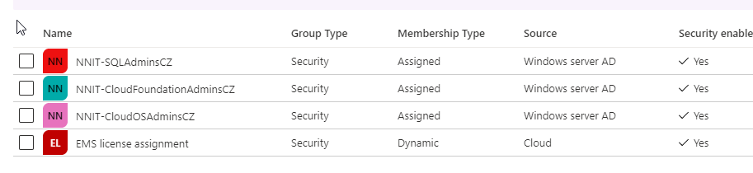

These accesses need to be requested in AccessIT.

## Application responsible

The application configuration is the customer responsibility along with Microsoft as a platform provider can be contacted in case of further support.

## Technical requirements and tools

The most common way of connection to the databases and instances is usually through SSMS (SQL Server Management Studio) which is installed on all jumphosts and it is recommendable to have it installed in your personal computer.

PowerShell is also a useful tool for multiple purposes for example when managing multiple servers at once. On all jumphosts is installed the module dbatools.

The connection to a Azure SQL Database can be done via Azure Data Studio and it can be launched from the portal but must be installed locally in your computer.

# System contents

## Operations model - system level

| **Service Level Target** | **Details** | **24/7** |
| --- | --- | --- |
| Service Hours | The time period where the services covered are expected to be available and where incident management will be performed. | No |
| Change and general request Fulfillment | The time period where the services covered is subject to Request fulfilment and Change Management. Activities related to other supporting processes are also covered in this category unless otherwise stated.  For details on targets for each process please refer to the NNIT Cloud Delivery Model | No |

## Azure SQL overview

Current Azure SQL resources are [here](https://portal.azure.com/#blade/HubsExtension/BrowseResource/resourceType/Microsoft.Sql%2Fazuresql)

**Discovering all SQL databases on a subscription:**

[SQL databases - Microsoft Azure](https://portal.azure.com/#blade/HubsExtension/BrowseResource/resourceType/Microsoft.Sql%2Fservers%2Fdatabases)

# Cloud Operations tagging for Azure SQL services

Cloud operations team defines the service delivering models according to the following SCT:

<https://nnit.sharepoint.com/sites/WS-Cloud/Shared%20Documents/Offering%20and%20Service%20Catalogue/03%20Services/Cloud%20SQL%20(Cloud%20Managed%20Service)/Azure%20SQL%20V1.0.docx?web=1>

Each particular SQL resource must be tagged according to the type of resource and service level support, this helps to identify what Cloud Operations team supports and its SLAs.

[NNIT] [Unmanaged Operation]

[NNIT] [Full Operation]

[NNIT] [Only Backup Operation]

.

# User management

6.1. Connecting to a Azure SQL database

1. In PowerShell or CMD type SSMS and press enter.



1. Click on Database Engine

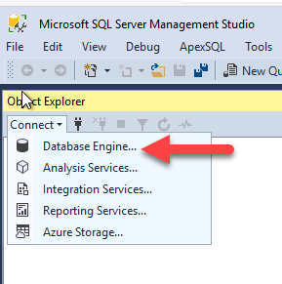

1. Type the database you need to connect to and authenticate in Azure and select Active Directory – Universal with MFA authentication:

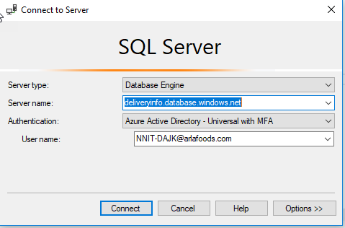

6.2. Connecting to a Azure SQL on VM instance

You can connect to the Windows OS and this is possible from both jump hosts AF-WIN-P-JMP-02 (Arla digital domain) or arltsdk425 and from there start Management Studio (SSMS) by typing in PowerShell or CMD:



6.3. Select Database Engine



6.4. Type your instance name and then select Windows Authentication and use your domain account.

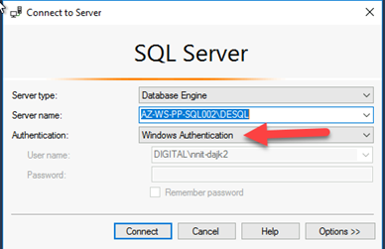

6.5. Adding users to an SQL Azure database:

Make sure you have a Service Request assigned to Cloud Operations team in Remedy.

Open a new query window and run

|  |
| --- |
| CREATE LOGIN "UserName" WITH password='StrongPassword';  USE YorDatabase  CREATE USER "UserName"  FOR LOGIN " UserName "WITH DEFAULT\_SCHEMA = dbo  GO  USE YorDatabase  GO  ALTER ROLE db\_datareader ADD MEMBER "UserName"  GO |

Then you can verify that the users were created with this script:

|  |
| --- |
| select name as username,  create\_date,  modify\_date,  type\_desc as type,  authentication\_type\_desc as authentication\_type  from sys.database\_principals  where type not in ('A', 'G', 'R', 'X')  and sid is not null  order by username; |

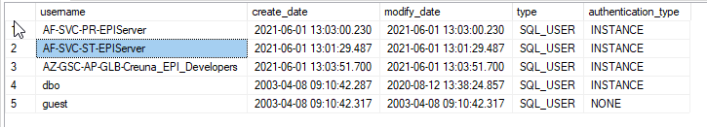

6.6. Adding users to a SQL Instance (Azure SQL on VM and Azure SQL Managed Instance)

When adding domain users accounts is preferable to add users to a Active directory group, for example NNIT-SQLAdminsCZ and then add the group into the instance. This is the best practice but if customer requires to add an particular user, then please follow the same procedure as below:

1. Make sure you have a ticket in Remedy and the user name
2. Right click on Logins and select New login:

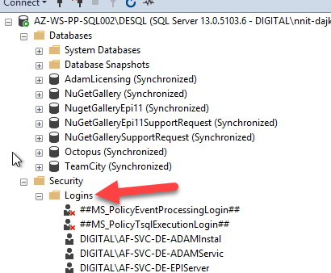

1. Insert the AD group

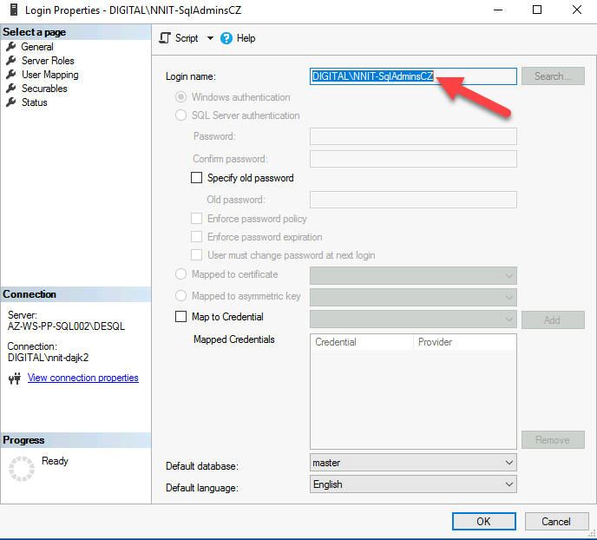

1. Click on Server Roles

By default, we do not provide sysadmin rights on an instance unless is stated in the Remedy ticket

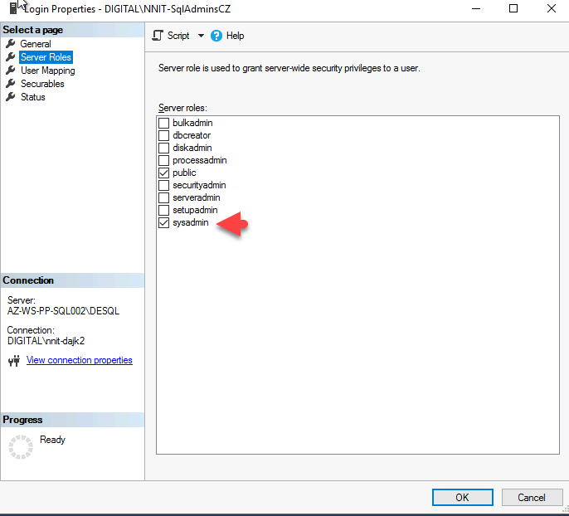

1. Click on User Mapping

Select the database the user needs access to. Then select the role. By default, we provide only db\_datareader if not other role is specified in the Remedy ticket.

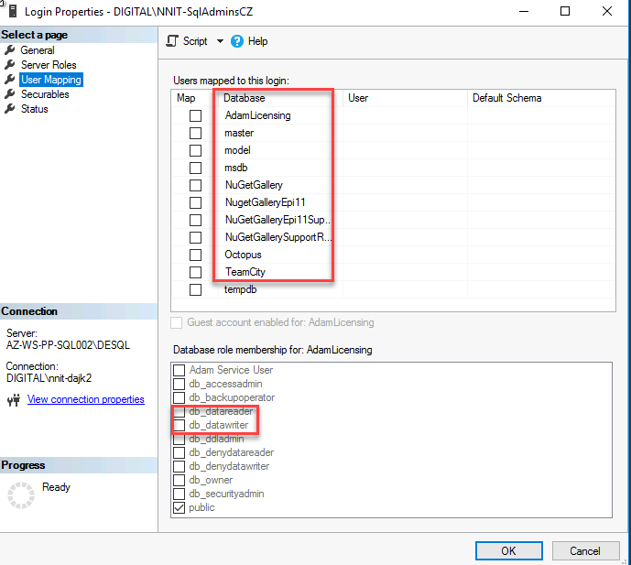

1. Click OK.

6.7. In order to connect to the database from internet you might need to add a firewall rule adding your client IP and for it you will need a user or group with role assignment for example:

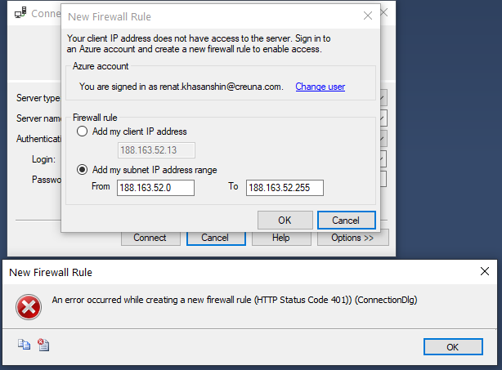



To be able to create and manage IP firewall rules for the Azure SQL Server, you will need to either be:

in the SQL Server Contributor role

in the SQL Security Manager role

Detailed information related Azure SQL databases and FW rules can be found [here](https://docs.microsoft.com/en-us/azure/azure-sql/database/firewall-configure#permissions).

# Deploying a database

7.1. In order to deploy a new database a new Request for Change in Remedy must be raised and assigned to Cloud Operations team. The Remedy template used is “New PaaS SQL Instance” The following requirements must be provided from the customer

|  |  |  |
| --- | --- | --- |
| Question/ requester input | Mandatory | Selection Values  (Default value first, delete values not required) |
| What would be the preferred name for a SQL Database? | Yes |  |
| What application name is the DB used by? | Yes | Application name |
| Environment for DB | Yes | Example: Development |
| Existing SQL PaaS Instance to place the database in. (if 'new SQL PaaS instance', please request this via a demand) | No |  |
| Refer if any existing SQL PaaS server name | No |  |
| DB Owner Name and contact | Yes |  |
| How the application using the DB will be published | Yes |  |
| What kind of application will be using this DB *(Web application any warehouse kind of requirement etc. Please brief on the project/ application usage.)* | Yes |  |
| Please provide approximate count of users to whom this application will be published. | Yes |  |
| Criticality of the Application | No |  |
| DB Read/Write permission will be provided by Default: (Please mention if any users with special permissions need to be created) | No |  |
| Please specify the SQL elastic pool if the database must be placed in one? | Yes |  |
| Tags to be added to this resource | No |  |
| Server admin login | Yes |  |
| Resource group | Yes |  |
| Subscription name | Yes |  |
| Collation | Yes | Default is SQL\_Latin1\_General\_CP1\_CI\_AS |
| Purchase model | Yes | vCore or DTU specify according Microsoft [here](https://azure.microsoft.com/en-us/pricing/details/azure-sql-database/single/) |
| High Availability | Yes |  |
| Backup requirement (Standard or LTR) | Yes |  |

7.2. Example of deploying an Azure PaaS database on an existing server using PowerShell:

New-AzSqlDatabase -ServerName "dajksqlserver01" -DatabaseName "dajkDatabase03" -Vcore 2 -ResourceGroupName "DAJK\_SQL" -Edition GeneralPurpose -ComputeGeneration Gen5 -MinimumCapacity 5GB -CollationName "SQL\_Latin1\_General\_CP1\_CI\_AS" -Verbose

# Deleting (decommissioning) a database

In order to delete a database a request must have been received through Remedy. Email or phone is NOT acceptable request path.

Make sure the latest backup are in place.

|  |  |
| --- | --- |
| **Customer provided information** | |
| Request ID | \_\_\_\_\_\_\_\_\_\_\_\_\_\_\_\_\_\_\_\_ |
| DM Confirmation | Yes,  No  If the deletion is not requested by the DM, get a written approval of the deletion from the DM and attach it to the remedy ticket. An email is sufficient. |
| Database name | \_\_\_\_\_\_\_\_\_\_\_\_\_\_\_\_\_\_\_\_\_\_\_\_\_\_\_\_\_.\_\_\_\_\_\_\_\_\_\_\_\_\_\_\_\_\_\_\_\_\_\_\_\_\_\_\_\_\_\_\_\_\_\_\_\_\_  Server and Database name must be |

8.1. Example of deleting a Azure PaaS database using PowerShell:

Remove-AzSqlDatabase -ServerName "dajksqlserver01" -DatabaseName "dajkDatabase03" -ResourceGroupName "DAJK\_SQL" -Verbose

# Adding and removing locks

# Checking database consistency in multiple databases in the same instance

From the jumphost use Powershell:

*Get-DbaLastGoodCheckDb -SqlInstance "AZ-WS-PR-SQL001\PRADM"*

Or connecting to the instance via Management Studio (SSMS).

Open a new query window and paste the following script:

|  |
| --- |
| IF OBJECT\_ID('tempdb..#DBInfo') IS NOT NULL  Drop TABLE #DBInfo  IF OBJECT\_ID('tempdb..#Value') IS NOT NULL  Drop TABLE #Value  CREATE TABLE #DBInfo (ParentObject VARCHAR(255), [Object] VARCHAR(255), Field VARCHAR(255), [Value] VARCHAR(255))  CREATE TABLE #Value (DatabaseName VARCHAR(255), LastDBCCCheckDB DATETIME)  EXECUTE sp\_MSforeachdb '  INSERT INTO #DBInfo EXECUTE ("DBCC DBINFO ( ""?"" ) WITH TABLERESULTS");  INSERT INTO #Value (DatabaseName, LastDBCCCheckDB) (SELECT "?", [Value] FROM #DBInfo WHERE Field = "dbi\_dbccLastKnownGood");  TRUNCATE TABLE #DBInfo;  '  SELECT \* FROM #Value  WHERE DatabaseName NOT IN ('tempdb')  IF OBJECT\_ID('tempdb..#DBInfo') IS NOT NULL  Drop TABLE #DBInfo  IF OBJECT\_ID('tempdb..#Value') IS NOT NULL  Drop TABLE #Value |

# Backup and Restore

11.1. Backup default configurations on Azure SQL databases

Both Azure SQL Database and Azure Managed Instance are immediately automatically backed up after being deployed and a point-in-time restore.

11.2. Backup SQL Server on Azure VM

An overview of the status of all SQL in Azure

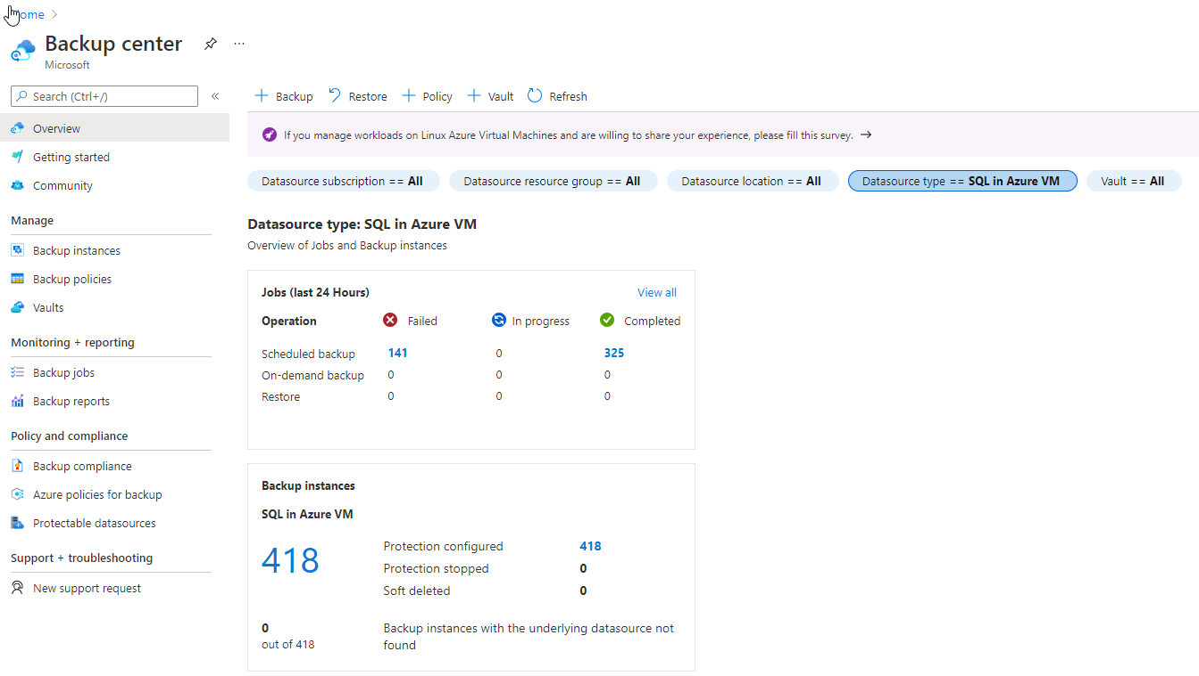

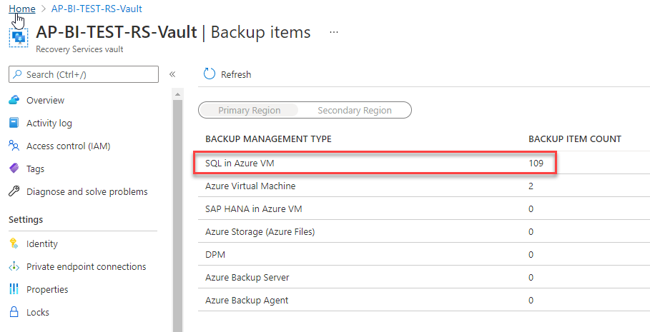

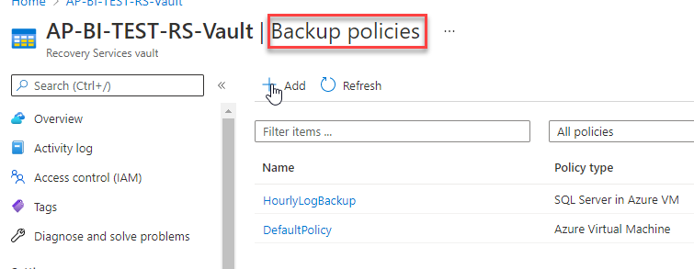

11.3. Restore a PaaS database withing the same server

This is in fact a creation of a copy of a particular database. Be sure that you have in the request:

- Server name

- Original database name

- Target database name

- Access to the SQL server, example in the picture. So you can connect via Management Studio (SSMS) using MFA authentication.

- If the database will be restored in the same server you will need to restore it with a different name and then rename it via SSMS

Click on “Restore”

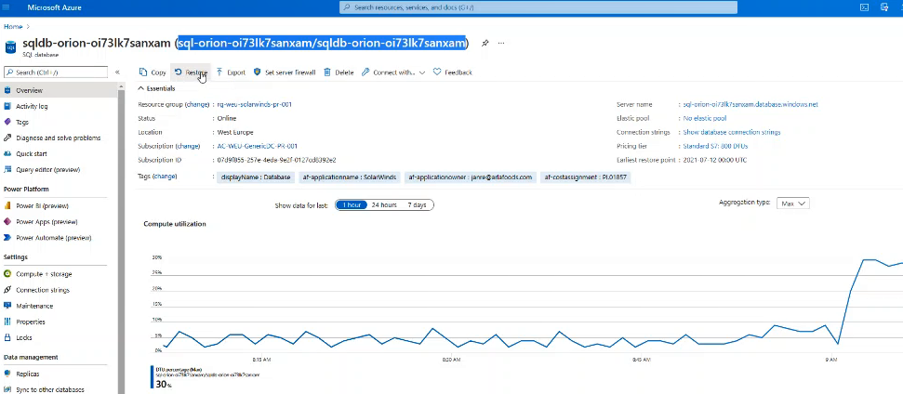

11.4. Select the point-in-time

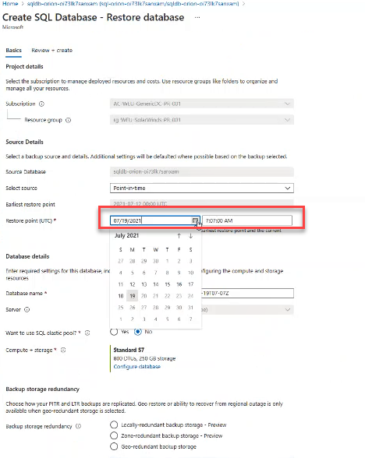

11.5. Insert the required database name and click Create.

11.6. Refresh the SQL server on the Management Studio and check if the new database is restoring.

In order to see the status of the restore job, open a new query in SSMS and execute the following scripts:

SELECT r.session\_id,r.command,CONVERT(NUMERIC(6,2),r.percent\_complete)

AS [PERCENT Complete],CONVERT(VARCHAR(20),DATEADD(ms,r.estimated\_completion\_time,GETDATE()),20) AS [ETA COMPLETION TIME],

CONVERT(NUMERIC(6,2),r.total\_elapsed\_time/1000.0/60.0) AS [Elapsed MIN],

CONVERT(NUMERIC(6,2),r.estimated\_completion\_time/1000.0/60.0) AS [ETA MIN],

CONVERT(NUMERIC(6,2),r.estimated\_completion\_time/1000.0/60.0/60.0) AS [ETA Hours],

CONVERT(VARCHAR(100),(SELECT SUBSTRING(TEXT,r.statement\_start\_offset/2,

CASE WHEN r.statement\_end\_offset = -1 THEN 1000 ELSE (r.statement\_end\_offset-r.statement\_start\_offset)/2 END)

FROM sys.dm\_exec\_sql\_text(sql\_handle)))

FROM sys.dm\_exec\_requests r WHERE command IN ('RESTORE DATABASE','BACKUP DATABASE')

SELECT \* FROM sys.dm\_exec\_requests

To see the ETA remaining you need to run the following command because the ETA is not visible on the portal:

SELECT \* FROM sys.dm\_operation\_status

11.7. Renaming the database

If the request is to restore one particular database to the same server then after restoring with a different name you have to rename it via SSMS.

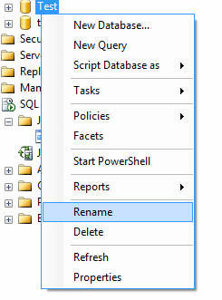

Or via TSQL: ALTER DATABASE [Test] MODIFY NAME = [Test2]

# Monitoring

The main monitoring point for all types of SQL Azure instances is SQL Insights:

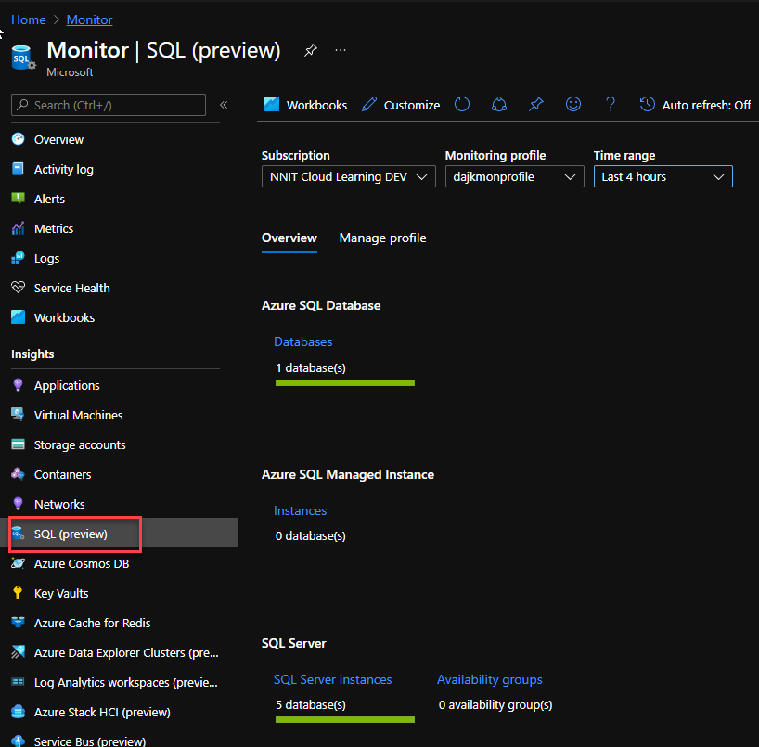

In order to add a new instance of you have to edit the configuration profile:

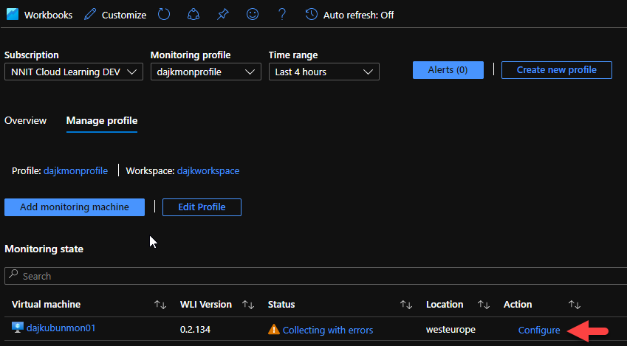

And add a new line into the following code:

|  |
| --- |
| {    "secrets": {      "telegrafPassword": {        "name": "telegraf",        "keyvault": "<https://dajkkeyvault.vault.azure.net/>"      }    },    "version": 1,    "parameters": {      "sqlAzureConnections": [        "Server=dajksqlserver01.database.windows.net;Port=1433;Database=dajktestsqldb;User Id=telegraf;Password=Lacandela2022;"      ],      "sqlVmConnections": [        "Server=10.2.0.4;Port=1433;User Id=telegraf;Password=Lacandela2022;"      ],      "sqlManagedInstanceConnections": []    }  } |

Instructions from Microsoft are [here](https://docs.microsoft.com/en-us/azure/azure-monitor/insights/sql-insights-enable).

Make sure your computers are connected to your log analytics workspace including the Ubuntu monitoring machine.

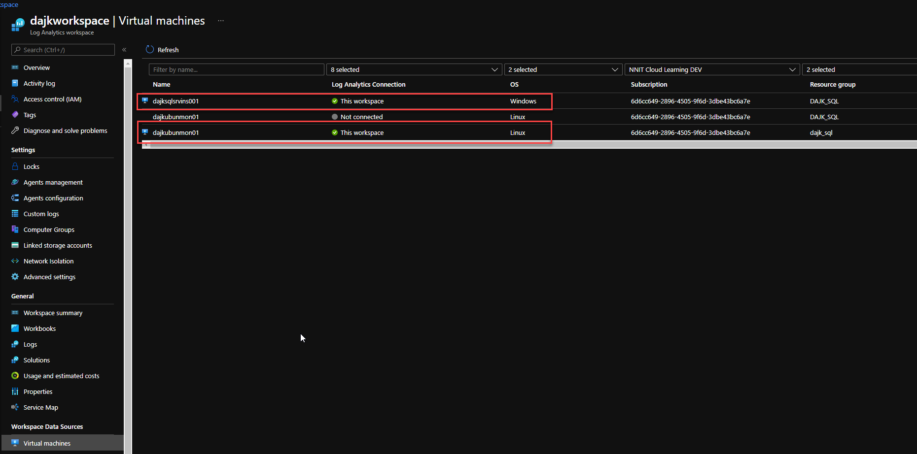

# AlwaysOn Availability Groups

Always On availability groups on Azure Virtual Machines are similar to Always On availability groups on-premises, and rely on the underlying Windows Server Failover Cluster. This solution is in place in Arla.

To check the Always On Availability status of the replicas you need to right click on “Availability groups”.

All databases participating on AG must be in state “Synchronizing”:

Machine generated alternative text:
Edit Viewu Project Debug Tools Windowu Help 
Neuu Query 
Object Explorer 
Connect • 
Al'.maysOn High Availability 
Availability Groups 
(Secondary) 
Availability Replicas 
DAFSQLDK025\105 
DAFSQLDK026\105 
DAFSQLDK035\105 (Secondary) 
Availability Databases 
aca net eRernaI 
acabatch 
DMVS 
FmkBase 
mssql_pharmanetbase 
PharmaNetLlserAdministration 
ProductCataIogue 
Availability Group Listeners 
Management 
Integration Services Catalogs 
SQL Server Agent 
DAFSQLDK026\105 (SQL Server 12.0.4522.0 
- nnit-dajk) 
Databases 
Security 
Server Objects 
Al'.maysOn High Availability 
Availability Groups 
(Primary) 
Availability Replicas 
DAFSQLDK025\105 (Secondary) 
DAFSQLDK026\105 (Primary) 
DAFSQLDK035\105 (Secondary) 
Availability Databases 
Availability Group Listeners 
Management 
Integration Services Catalogs 
SQL Server Agent 
SQLQuery5.sqI - DAF...r (nnit-dajk 
Group by • 
Name 
SQL Query3.sqI - 10.2...ter (nnit-dajk 
hosted by DAFSQLDK026\105 (Replica role: Primary) 
0 
0 
0 
0 
aca net external 
acabatch 
DMVS 
FmkBase 
mssql_pharmanetbase 
PharmaNetLlserAdmini„ 
ProductCataIogue 
DAFSQLDK026\105 
0 
aca net 
aca net external 
0 
acabatch 
0 
DMVS 
FmkBase 
0 
mssql_pharmanetbase 
PharmaNetLlserAdmini„ 
0 
ProductCataIogue 
0 
DAFSQLDK035\105 
0 
aca net 
aca net external 
0 
acabatch 
0 
DMVS 
FmkBase 
0 
mssql_pharmanetbase 
PharmaNetLlserAdmini„ 
0 
ProductCataIogue 
0 
DAFSOLDK025\105 
DAFSOLDK025\105 
DAFSOLDK025\105 
DAFSOLDK025\105 
DAFSOLDK025\105 
DAFSOLDK025\105 
DAFSOLDK025\105 
DAFSOLDK025\105 
DAFSOLDK025\105 
DAFSOLDK028\105 
DAFSOLDK028\105 
DAFSOLDK028\105 
DAFSOLDK028\105 
DAFSOLDK028\105 
DAFSOLDK028\105 
DAFSOLDK028\105 
DAFSOLDK028\105 
DAFSOLDK028\105 
DAFSOLDK028\105 
DAFSOLDK035\105 
DAFSOLDK035\105 
DAFSOLDK035\105 
DAFSOLDK035\105 
DAFSOLDK035\105 
DAFSOLDK035\105 
DAFSOLDK035\105 
DAFSOLDK035\105 
DAFSOLDK035\105 
DAFSOLDK035\105 
Synchronization State 
Synchronized 
Synchronized 
Synchronized 
Synchronized 
Synchronized 
Synchronized 
Synchronized 
Synchronized 
Synchronized 
Synchronized 
Synchronized 
Synchronized 
Synchronized 
Synchronized 
Synchronized 
Synchronized 
Synchronized 
Synchronized 
Synchronized 
Synchronizing 
Synchronizing 
Synchronizing 
Synchronizing 
Synchronizing 
Synchronizing 
Synchronizing 
Synchronizing 
Synchronizing 
Synchronizing 
Failover Readi... 
No Data Loss 
No Data Loss 
No Data Loss 
No Data Loss 
No Data Loss 
No Data Loss 
No Data Loss 
No Data Loss 
No Data Loss 
No Data Loss 
No Data Loss 
No Data Loss 
No Data Loss 
No Data Loss 
No Data Loss 
No Data Loss 
No Data Loss 
No Data Loss 
No Data Loss 
Data Loss 
Data Loss 
Data Loss 
Data Loss 
Data Loss 
Data Loss 
Data Loss 
Data Loss 
Data Loss 
Data Loss 

# Security

# Definitions and references

## Acronyms and definitions

The table lists acronyms used in the document, including definitions of technical concepts.

|  |  |
| --- | --- |
| **Acronym/Definition** | **Description** |
|  |  |
|  |  |

## Referenced documents

The table provides an overview of relevant references.

|  |  |
| --- | --- |
| **Document ID** | **Document** |
|  |  |
|  |  |

# Change log

|  |  |  |  |
| --- | --- | --- | --- |
| **Date** | **Version** | **Description of changes** | **Initials** |
|  |  |  |  |
|  |  |  |  |